**Unit 1 Labs** (5 points)

To begin a new program, open JGRASP.

Choose File 🡪 New 🡪 Java

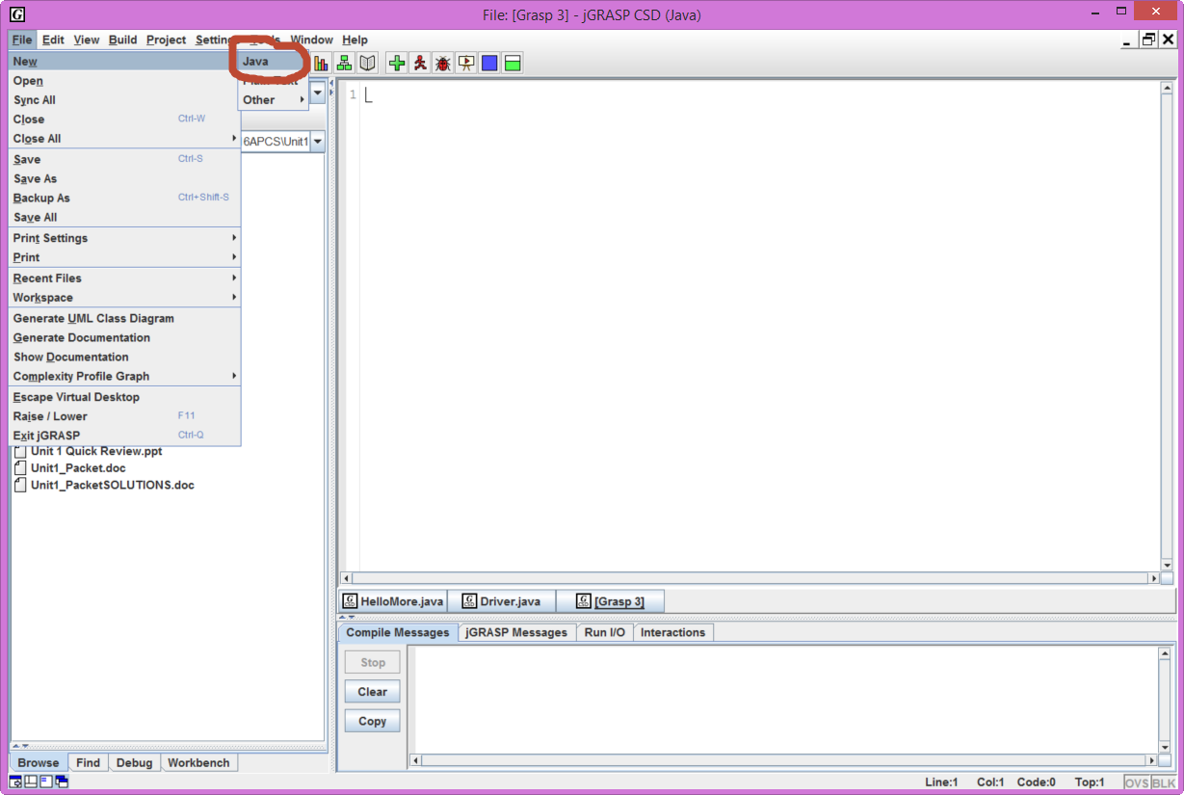

SAVE your file first and assign a name.

Choose File 🡪 Save As🡪 Lab01A (Java is case-sensitive)

**Lab01A**

Enter, compile, and run the following program:

1 // Lab01A.java mm/dd/yyyy  
 2 //  
 3 // @author - Ima Programmer  
 4 // @author - Period n  
 5 // @author - ID 2nnnnn | Ursuline Academy of Dallas  
 6 //  
 7 // Honorbound: I received help from (insert name here)

8 // and I commented the line # where I received help

9 public class Lab01A  
10 {  
11 public static void main (String [] args)  
12 {  
13 System.out.println ("Hello World");  
14 }  
15 }

Find and run main method

Compile file

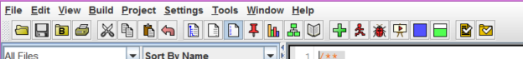

**Lab01B**

Introduce the following errors into the program above (Lab01A).

* Make the changes ONE AT A TIME, ***recompile***,
* Write (not type) the error message(s) in the space provided
* Do not copy/paste…
* If you have more than one error for the item, just write the first error.
* Fix the previous error each time before you go to the next.
* If no error happens, just write "no compiler error"

a. change Lab01A to Lab01X

b. change Hello to HELLO

c. remove the first quotation mark in the string

d. remove the last quotation mark in the string

e. change main to man _____________________________________________________

1. change println to bob
2. remove the semicolon at the end of the println statement
3. remove the last brace (}) in the program

**Lab01C – begin with starter code**

Think of a goal for yourself for this class! Write a program that will print (on separate lines) a poem about your goals. You should have at least 4 lines of output.

**Lab01D – begin with starter code**

Write a program class called Lab01D that ***assigns*** 3 integer variables: hours, minutes, and seconds. Based on those numbers, calculate the same time in seconds. Print the following output:

My Time Calculating Program

by: your name here

Hours: 1

Minutes: 28

Seconds: 42

New Time in Seconds: 5322

Change the numbers to: 0 hours, 3 minutes, 22 seconds. What answer do you get? Is it correct?

**Lab01E – begin with starter code**

Write a program class called Lab01E that works in reverse of the assignment above. **Ask the user** to enter the number of seconds and calculate the hours, minutes, seconds. Print the following output:

My Time Calculating Program - reverse

by: your name here

9999 seconds is equal to 2 hours, 46 minutes, and 39 seconds.

Change the original total = 360. What answer do you get? Is it correct?